**DAILY ONLINE ACTIVITIES SUMMARY**

|  |  |  |  |  |  |  |  |  |
| --- | --- | --- | --- | --- | --- | --- | --- | --- |
| **Date:** | **15/07/2020** | | | | | **Name:** | **NAIPUNYA VINOD NAIK** | |
| **Sem & Sec** | **IV SEM & A SECTION** | | | | | **USN:** | **4AL18CS050** | |
| **Online Test Summary** | | | | | | | | |
| **Subject** | | **OPERATING SYSTEMS** | | | | | | |
| **Max. Marks** | | **30** | | **Score** | | | **-----------** | |
| **Certification Course Summary** | | | | | | | | |
| **Course** | **1) LEARN ADVANCED JAVASCRIPT**  **2) LEARN REACT WITH SCRATCH**  **3) GOOGLE CLOUD PLATFORM BIG DATA AND MACHINE LEARNING FUNDAMENTALS** | | | | | | | |
| **Certificate Provider** | | | **1)UDEMY**  **2)UDEMY**  **3)COURSERA** | | **Duration** | | | **1) 2.5 HRS**  **2) 41 MIN**  **3) 2 WEEKS** |
| **Coding Challenges** | | | | | | | | |
| **Problem Statement: NO PROBLEM STATEMENT GIVEN TODAY** | | | | | | | | |
| **Status:-------------------------** | | | | | | | | |
| **Uploaded the report in Github** | | | | | **YES** | | | |
| **If yes Repository name** | | | | | <https://github.com/naipunya-naik/daily-progress-report> | | | |
| **Uploaded the report in slack** | | | | | **YES** | | | |

Online Test Details: (Attach the snapshot and briefly write the report for the same).

TODAY OPERATING SYSTEMS DESCRIPTIVE TEST-1 WAS CONDUCTED ON 15TH JULY 2020.

* SUBJECT:- OPERATING SYSTEMS
* CONDUCTED BY:- MRS. REENA LOBO
* FROM 9.20 AM TO 10:20AM
* DURATION:- 1 HR
* NO.OF QUESTIONS:- 4
* TOTAL MARKS:- 30
* MARKS WILL BE PROVIDED SOON
* DUE TO SLOW INTERNET, MY DOCUMENT GOT UPLOADED AT 10.22AM, SO IT TURNED IN LATE.

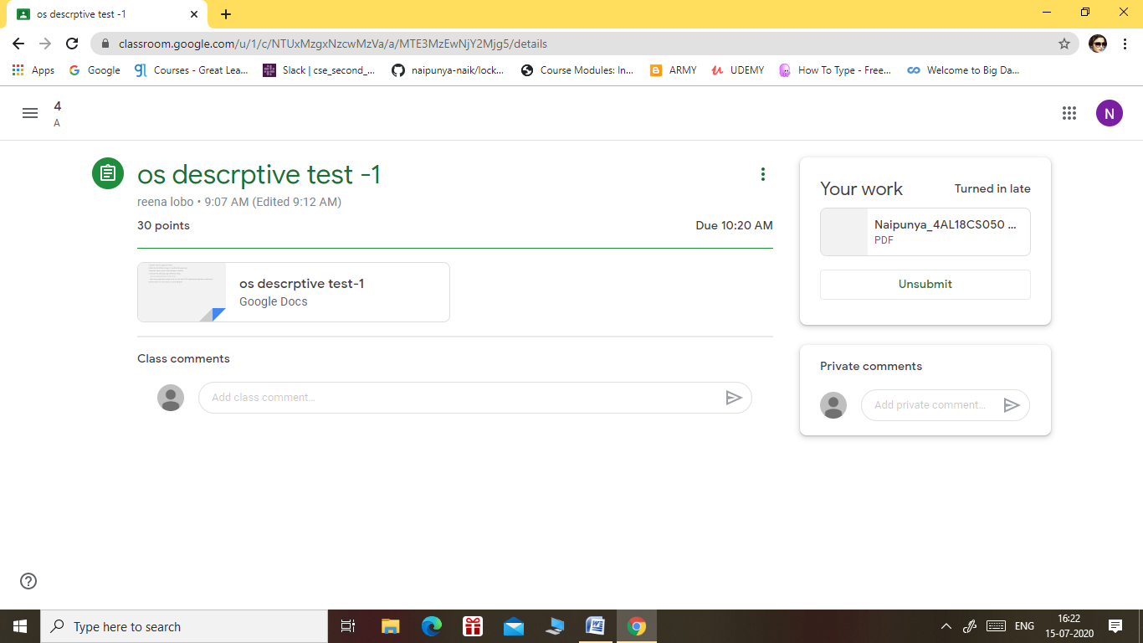

Certification Course Details: (Attach the snapshot and briefly write the report for the same).

CERTIFICATION COURSE NAME:- **LEARN ADVANCED JAVASCRIPT**

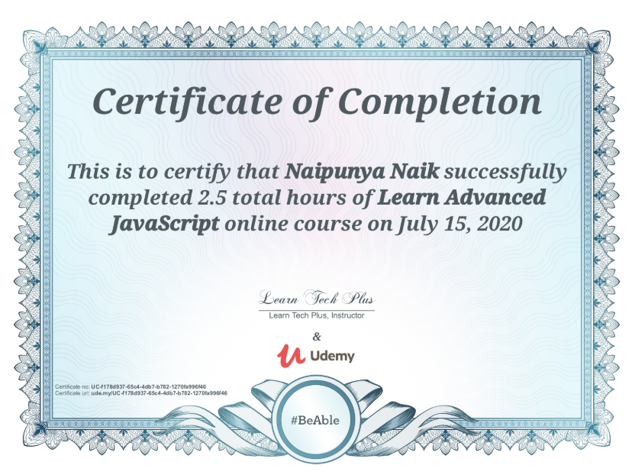

2) CERTIFICATION COURSE NAME:- **LEARN REACT WITH SCRATCH**

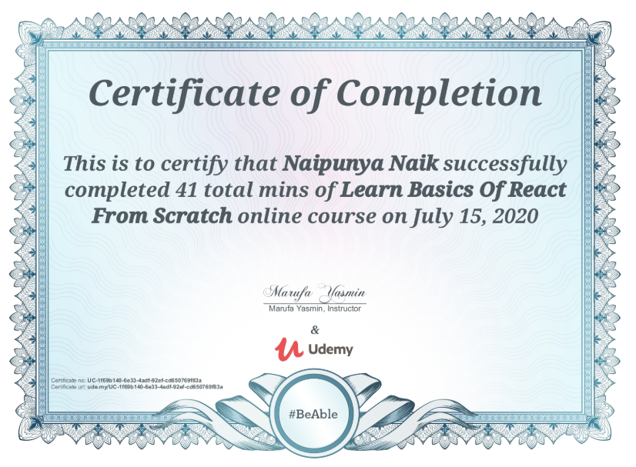

3) CERTIFICATION COURSE NAME:- **GOOGLE CLOUD PLATFORM BIG DATA AND MACHINE LEARNING FUNDAMENTALS**

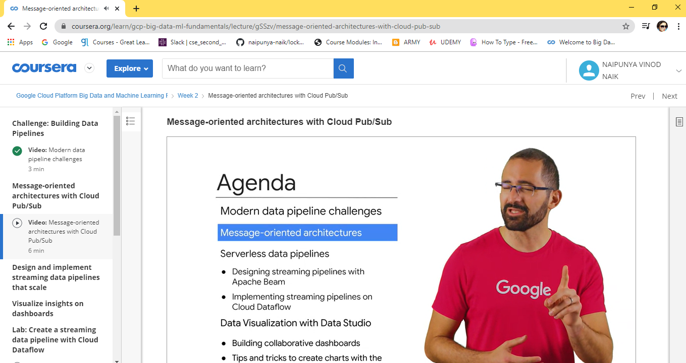

Coding Challenges Details: (Attach the snapshot and briefly write the report for the same).

NO PROBLEM STATEMENTS GIVEN TODAY